In [5]:

In [3]:

In [4]:

In [6]:

In [7]:

|  |  |  |  |  |
| --- | --- | --- | --- | --- |
| **import** sympy **as** sp **import** math | | | |  |
|  |  | | |  |
| x **=** | sp**.**Symbol('x') | | |  |
|  |  | | |  |
| f **=** | sp**.**Function('f') | | |  |
|  |  |  |  |  |
| f **=** | pow(x,3) | **+** | 2**\***x**\*\***2 | **+** 1 |
|  |  |  |  |  |
| display(f) | | | |  |

$\displaystyle x^{3} + 2 x^{2} + 1$

In [9]:

|  |
| --- |
| display(r'la courbe de f pour x = [-6,6]') sp**.**plot(f,(x,**-**6,6)) |

'la courbe de f pour x = [-6,6]'

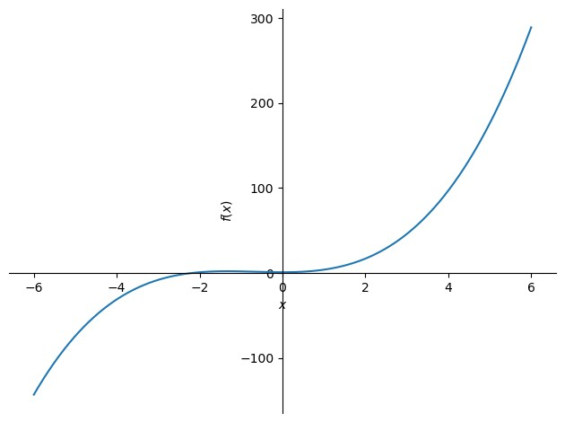

|  |
| --- |
| display(r'la courbe de f pour x = [5.4999,5.5001]') |

Out[9]: < sympy.plotting.backends.matplotlibbackend.matplotlib.MatplotlibBackend at 0x 20 e4c49dd00>

In [11]:

|  |
| --- |
| sp**.**plot(f,(x,5.4999,5.5001)) |

'la courbe de f pour x = [5.4999,5.5001]' In [13]:

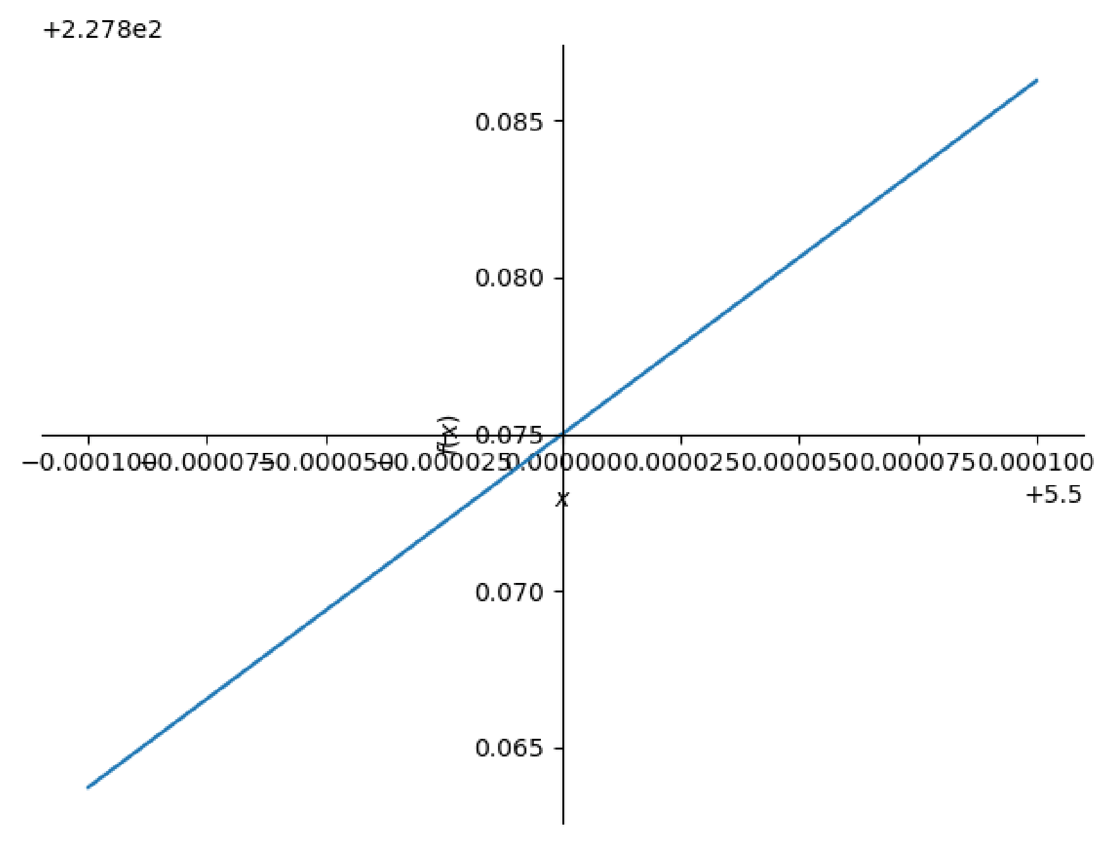

|  |
| --- |
| Vgauche **=** [5.4999,5.49999,5.499999] Vdroite **=** [5.500001,5.50001,5.5001] print('Limite à gauche')  Ugauche **=** [f**.**subs(x,i) **for** i **in** Vgauche] print(Vgauche) print(Ugauche) |

Out[13]: < sympy.plotting.backends.matplotlibbackend.matplotlib.MatplotlibBackend at 0x 20 e4ef4b5f0>

In [15]:

Limite à gauche

[5.4999, 5.49999, 5.499999]

|  |
| --- |
| print('limite à droite')  Udroite **=** [f**.**subs(x,i) **for** i **in** Vdroite] print(Vdroite) print(Udroite) |

[227.863725184999, 227.873872501850, 227.874887250018]

In [16]:

limite à droite

[5.500001, 5.50001, 5.5001]

|  |
| --- |
| print(sp**.**limit(f,x,5.5,'-')) |

|  |
| --- |
| print(sp**.**limit(f,x,5.5,'+')) |

[227.875112750019, 227.876127501850, 227.886275185001]

In [19]:

227.875000000000

In [20]:

|  |
| --- |
| **import** numpy **as** np **import** matplotlib.pyplot **as** plt **import** math |

227.875000000000 In [22]:

In [23]:

In [24]:

|  |  |  |  |
| --- | --- | --- | --- |
| x **=** | np**.**linspace(**-**6,6,100) | | |
|  |  |  |  |
| **def** | f(x): |  |  |
|  | **return** pow(x,3) | **+** | 2**\***x**\*\***2 **+** 1 |
|  |  |  |  |
| print(r'la courbe de f sur [-6,6]') plt**.**plot(x,f(x),"y") plt**.**show() | | | |

In [25]: la courbe de f sur [-6,6]

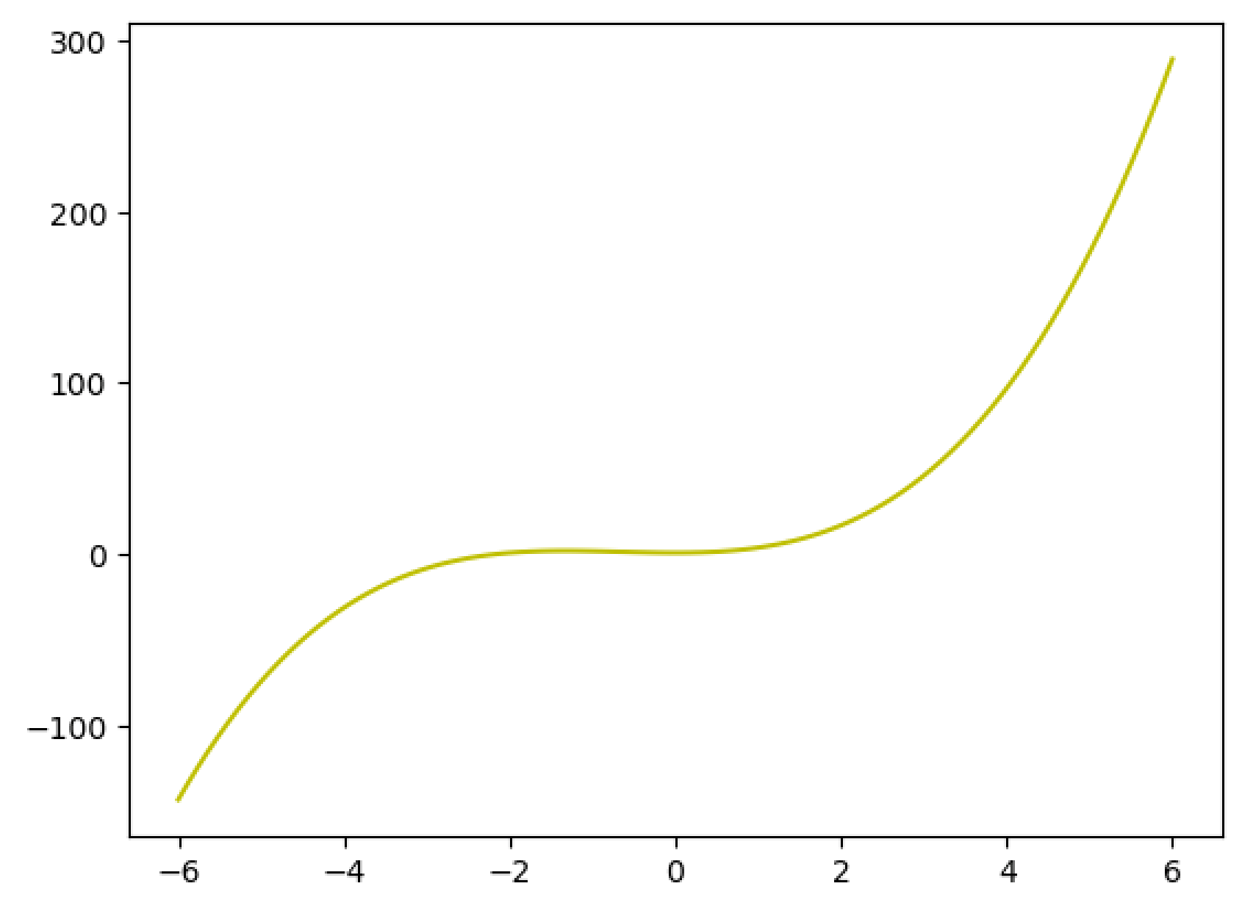

|  |
| --- |
| x **=** np**.**linspace(5.4999,5.5001,10) plt**.**plot(x,f(x),"b") plt**.**show() |

In [26]:

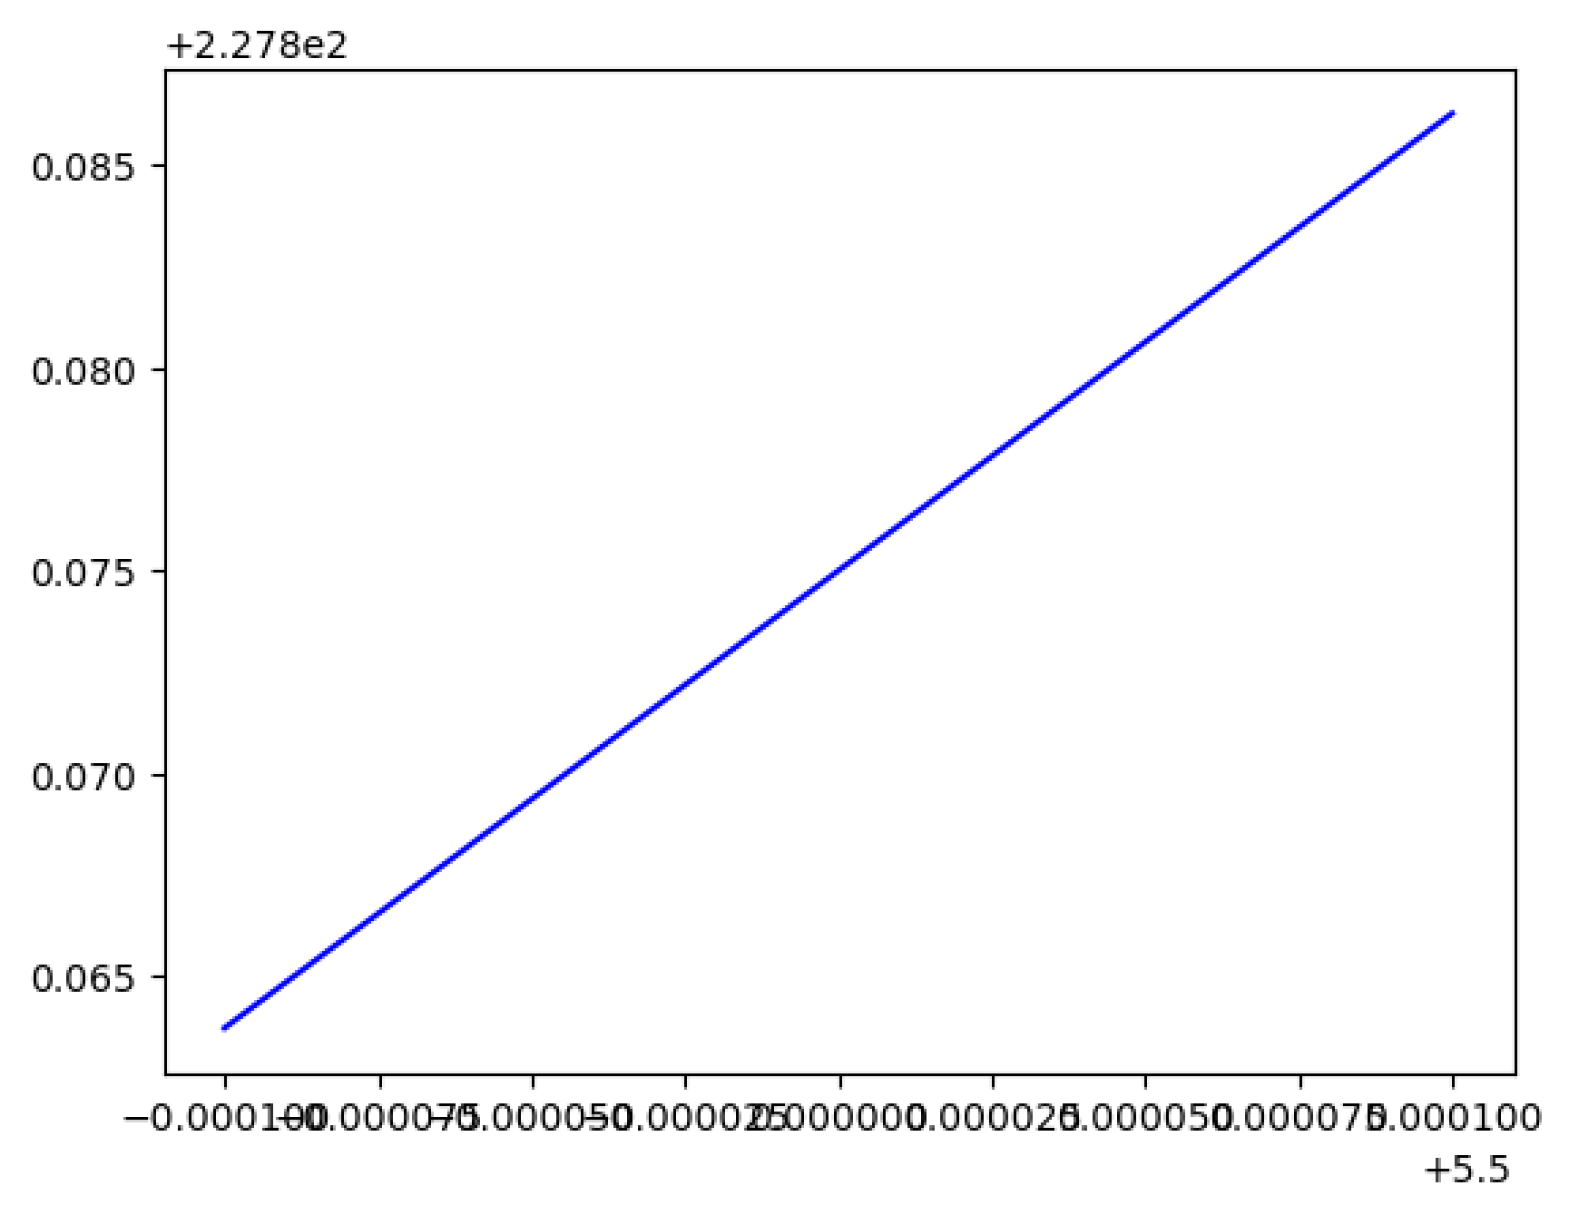

In [27]:

limite à gauche

[5.4999 5.49999 5.499999]

|  |
| --- |
| Vgauche **=** np**.**array([5.4999,5.49999,5.499999])  print("limite à gauche") Ugauche **=** f(Vgauche) print(Vgauche) print(Ugauche) |

|  |
| --- |
| Vdroite **=** np**.**array([5.500001,5.50001,5.5001])  print("limite à droite") Udroite **=** f(Vdroite) print(Vdroite) print(Udroite) |

[227.86372518 227.8738725 227.87488725]

In [29]:

limite à droite

[5.500001 5.50001 5.5001 ]

|  |
| --- |
|  |

[227.87511275 227.8761275 227.88627519] In [ ]:

In [80]:

In [81]:

In [82]:

In [83]:

In [84]:

|  |  |  |
| --- | --- | --- |
| **import** sympy **as** sp **import** math | | |
|  |  | |
| x **=** | sp**.**Symbol('x') | |
|  |  | |
| f **=** | sp**.**Function('f') | |
|  |  |  |
| f **=** | sp**.**ln(x) | **+** 12**\***x **+** 1 |
|  |  |  |
| display(f) | | |

$\displaystyle 12 x + \log{\left(x \right)} + 1$

In [89]:

'la courbe de f pour x = ]0,6]'

|  |
| --- |
| display(r'la courbe de f pour x = ]0,6]') sp**.**plot(f,(x,0,6)) |

< lambdifygenerated-29>:2: RuntimeWarning: divide by zero encountered in log return 12*x + log(x) + 1

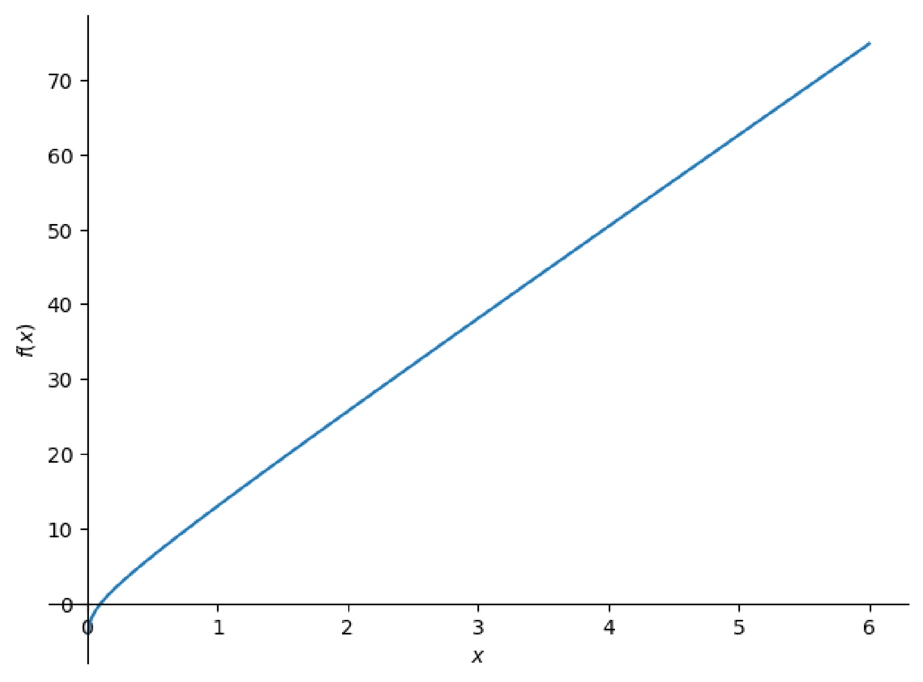

|  |
| --- |
| display(r'la courbe de f pour x = [4.9999,5.0001]') |

Out[89]: < sympy.plotting.backends.matplotlibbackend.matplotlib.MatplotlibBackend at 0x 20 e554be8d0>

In [90]:

|  |
| --- |
| sp**.**plot(f,(x,4.9999,5.0001)) |

'la courbe de f pour x = [4.9999,5.0001]' In [91]:

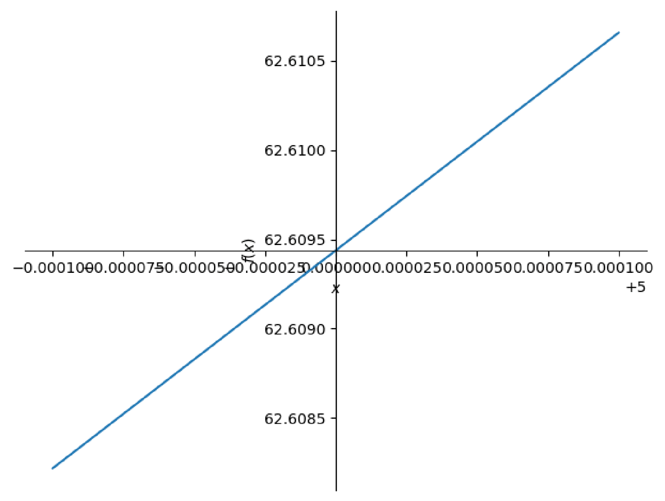

|  |
| --- |
| Vgauche **=** [4.9999,4.99999,4.999999] Vdroite **=** [5.000001,5.00001,5.0001] print('Limite à gauche')  Ugauche **=** [f**.**subs(x,i) **for** i **in** Vgauche] print(Vgauche) print(Ugauche) |

Out[91]: < sympy.plotting.backends.matplotlibbackend.matplotlib.MatplotlibBackend at 0x 20 e55763650>

In [92]:

Limite à gauche

[4.9999, 4.99999, 4.999999]

|  |
| --- |
| print('limite à droite')  Udroite **=** [f**.**subs(x,i) **for** i **in** Vdroite] print(Vdroite) print(Udroite) |

[62.6082179122341, 62.6093159124321, 62.6094257124341]

In [93]:

limite à droite

[5.000001, 5.00001, 5.0001]

|  |
| --- |
| **import** numpy **as** np  **import** matplotlib.pyplot **as** plt |

|  |
| --- |
| print(sp**.**limit(f,x,5,'-')) |

|  |
| --- |
| print(sp**.**limit(f,x,5,'+')) |

[62.6094501124341, 62.6095599124321, 62.6106579122341]

In [94]:

log(5) + 61

In [95]:

log(5) + 61

In [96]:

In [99]:

In [100…

In [101…

la courbe de f sur [0,6]

|  |  |
| --- | --- |
| x **=** | np**.**linspace(0,6,100) |
|  |  |
| **def** | f(x):  **return** np**.**log(x) **+** 12**\***x **+** 1 |
|  |  |
| print(r'la courbe de f sur [0,6]') plt**.**plot(x,f(x),"y") plt**.**show() | |

C:\Users\DELL E7440\AppData\Local\Temp\ipykernel_16776\756664542.py:2: RuntimeWar ning: divide by zero encountered in log return np.log(x) + 12*x + 1

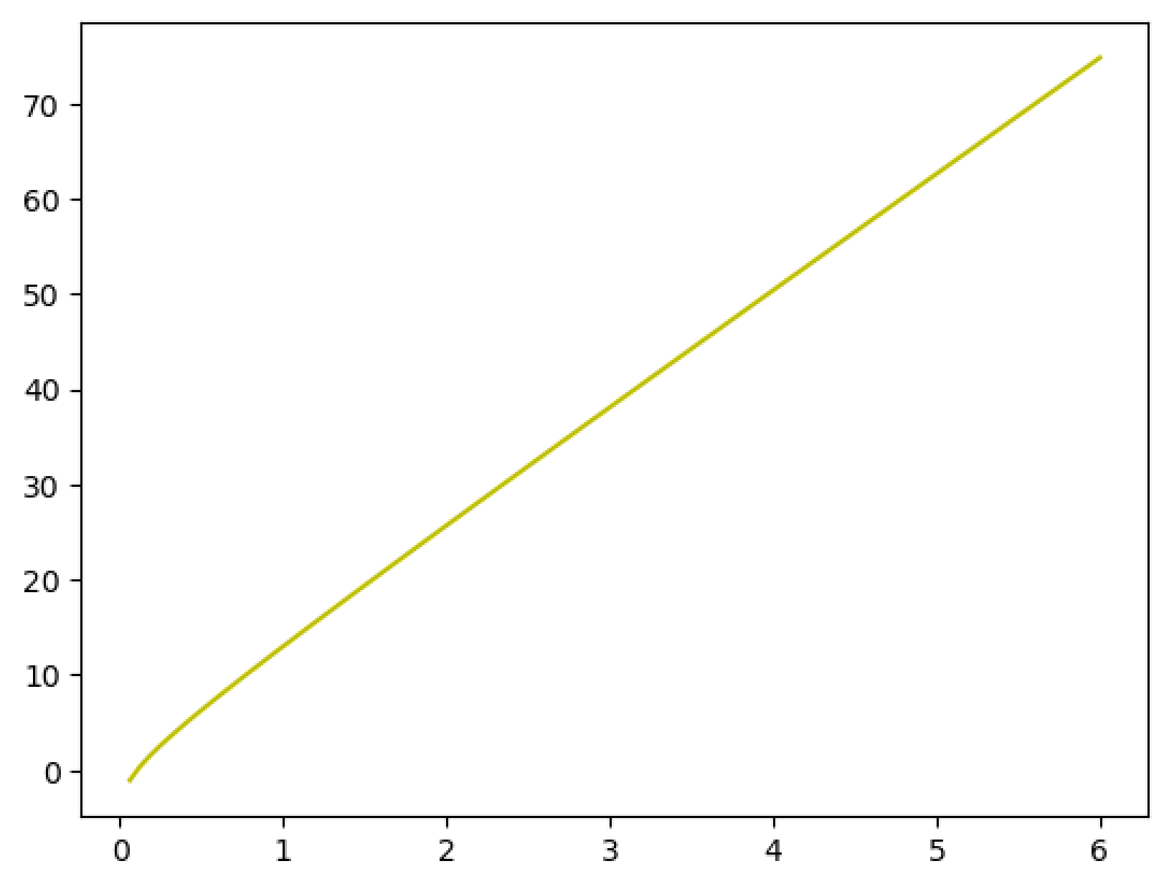

|  |
| --- |
| x **=** np**.**linspace(4.9999,5.0001,10) plt**.**plot(x,f(x),"b") plt**.**show() |

In [102…

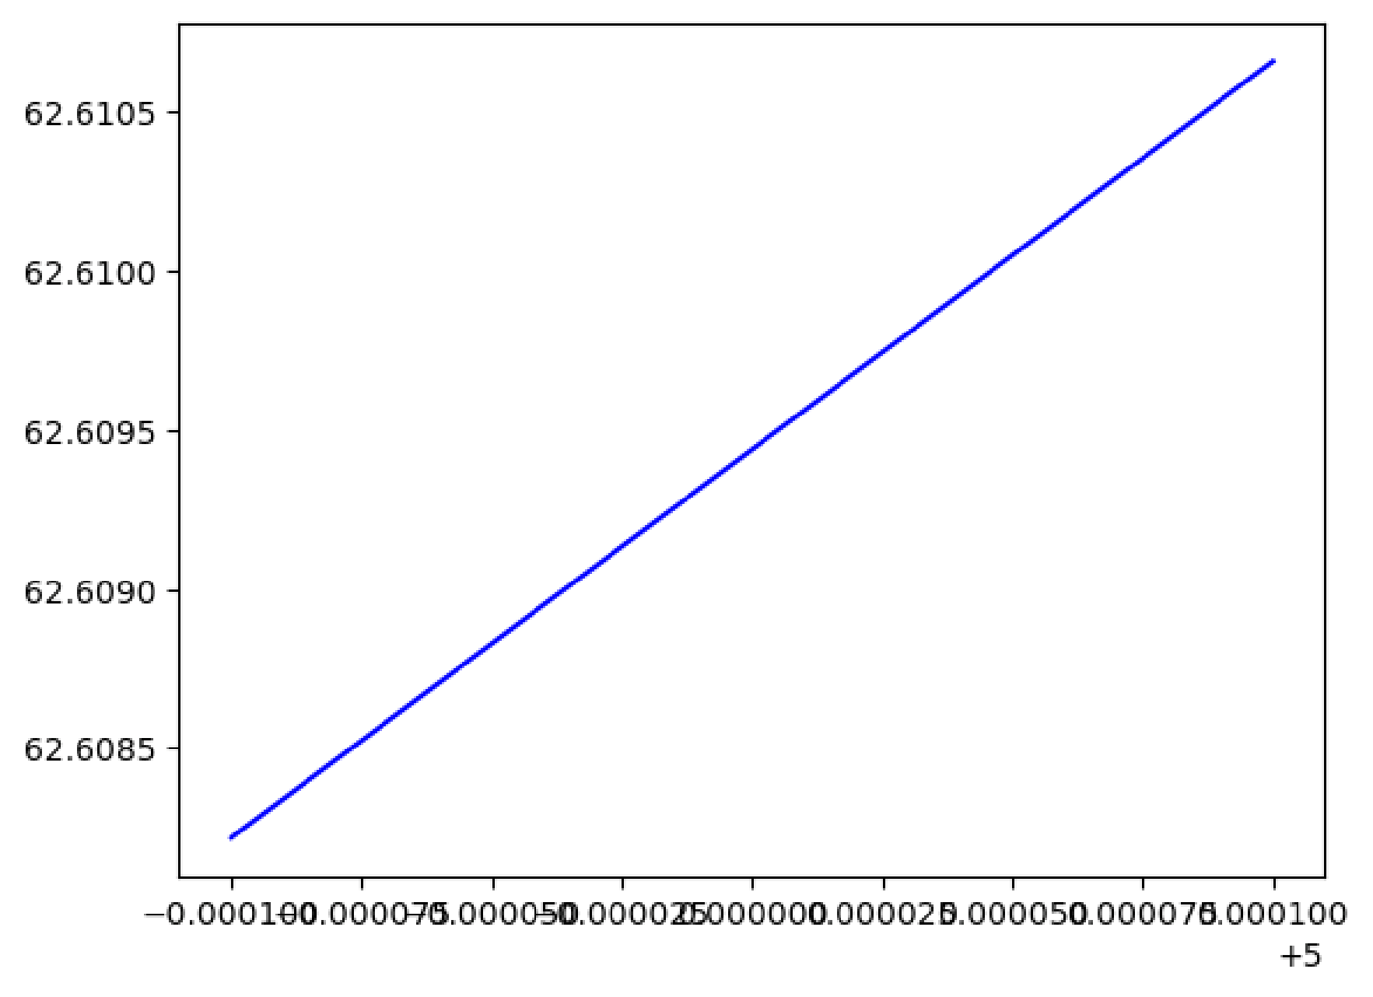

In [103…

limite à gauche

[4.9999 4.99999 4.999999]

|  |
| --- |
| Vgauche **=** np**.**array([4.9999,4.99999,4.999999])  print("limite à gauche") Ugauche **=** f(Vgauche) print(Vgauche) print(Ugauche) |

|  |
| --- |
| Vdroite **=** np**.**array([5.000001,5.00001,5.0001])  print("limite à droite") Udroite **=** f(Vdroite) print(Vdroite) print(Udroite) |

[62.60821791 62.60931591 62.60942571]

In [104…

limite à droite

[5.000001 5.00001 5.0001 ]

|  |
| --- |
|  |

[62.60945011 62.60955991 62.61065791] In [ ]:

In [110…

In [111…

In [112…

In [113…

In [114…

|  |
| --- |
| display(r'la courbe de f pour x = [-2,2]') sp**.**plot(f,(x,**-**2,2)) |

|  |  |  |  |
| --- | --- | --- | --- |
| **import** sympy **as** sp | | | |
|  |  | | |
| x **=** | sp**.**Symbol('x') | | |
|  |  | | |
| f **=** | sp**.**Function('f') | | |
|  |  |  |  |
| f **=** | x**\***sp**.**sin(x) | **+** | 5**\***x**\*\***2 **+** 1 |
|  |  |  |  |
| display(f) | | | |

$\displaystyle 5 x^{2} + x \sin{\left(x \right)} + 1$

In [115…

'la courbe de f pour x = [-2,2]'

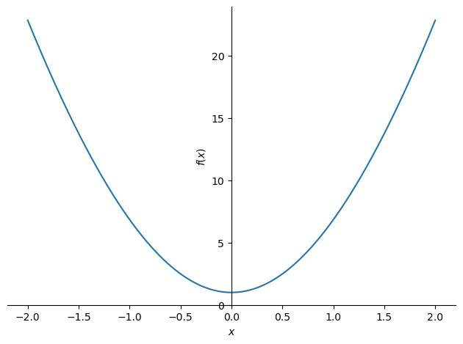

|  |
| --- |
| display(r'la courbe de f pour x = [1.9999,2.0001]') |

|  |
| --- |
| sp**.**plot(f,(x,1.9999,2.0001)) |

Out[115… < sympy.plotting.backends.matplotlibbackend.matplotlib.MatplotlibBackend at 0x 20 e557b53a0>

In [116…

'la courbe de f pour x = [1.9999,2.0001]'

In [117…

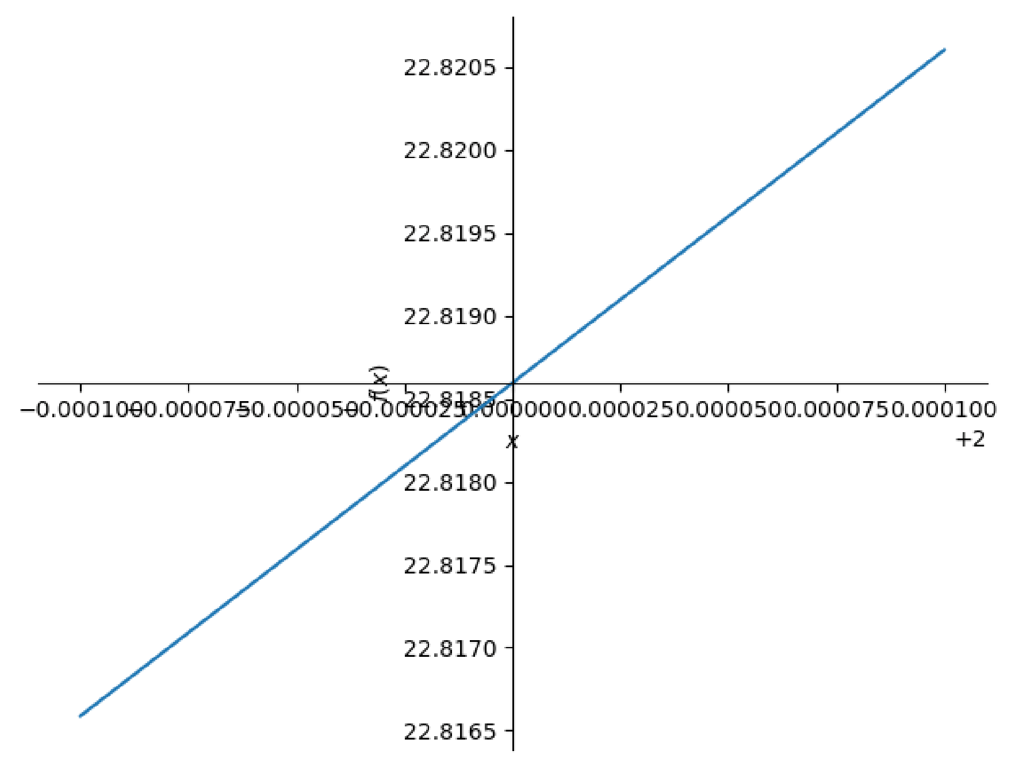

|  |
| --- |
| Vgauche **=** [1.9999,1.99999,1.999999] Vdroite **=** [2.000001,2.00001,2.0001] print('Limite à gauche')  Ugauche **=** [f**.**subs(x,i) **for** i **in** Vgauche] print(Vgauche) print(Ugauche) |

Out[117… < sympy.plotting.backends.matplotlibbackend.matplotlib.MatplotlibBackend at 0x 20 e55de5a30>

In [118…

Limite à gauche

[1.9999, 1.99999, 1.999999]

|  |
| --- |
| print('limite à droite')  Udroite **=** [f**.**subs(x,i) **for** i **in** Vdroite] print(Vdroite) print(Udroite) |

[22.8165871900219, 22.8183940839813, 22.8185747766513]

In [119…

limite à droite

[2.000001, 2.00001, 2.0001]

|  |
| --- |
| **import** numpy **as** np  **import** matplotlib.pyplot **as** plt |

|  |
| --- |
| print(sp**.**limit(f,x,2,'-')) |

|  |
| --- |
| print(sp**.**limit(f,x,2,'+')) |

[22.8186149306588, 22.8187956240564, 22.8206025907720]

In [120…

2 *sin(2) + 21

In [121…

2 *sin(2) + 21

In [130…

In [131…

In [132…

In [133…

|  |  |  |  |
| --- | --- | --- | --- |
| x **=** | np**.**linspace(**-**2,2,100) | | |
|  |  |  |  |
| **def** | f(x): |  |  |
|  | **return** | x**\***np**.**sin(x) **+** | 5**\***x**\*\***2 **+** 1 |
|  |  |  |  |
| print(r'la courbe de f sur [-2,2]') plt**.**plot(x,f(x),"r") plt**.**show() | | | |

la courbe de f sur [-2,2]

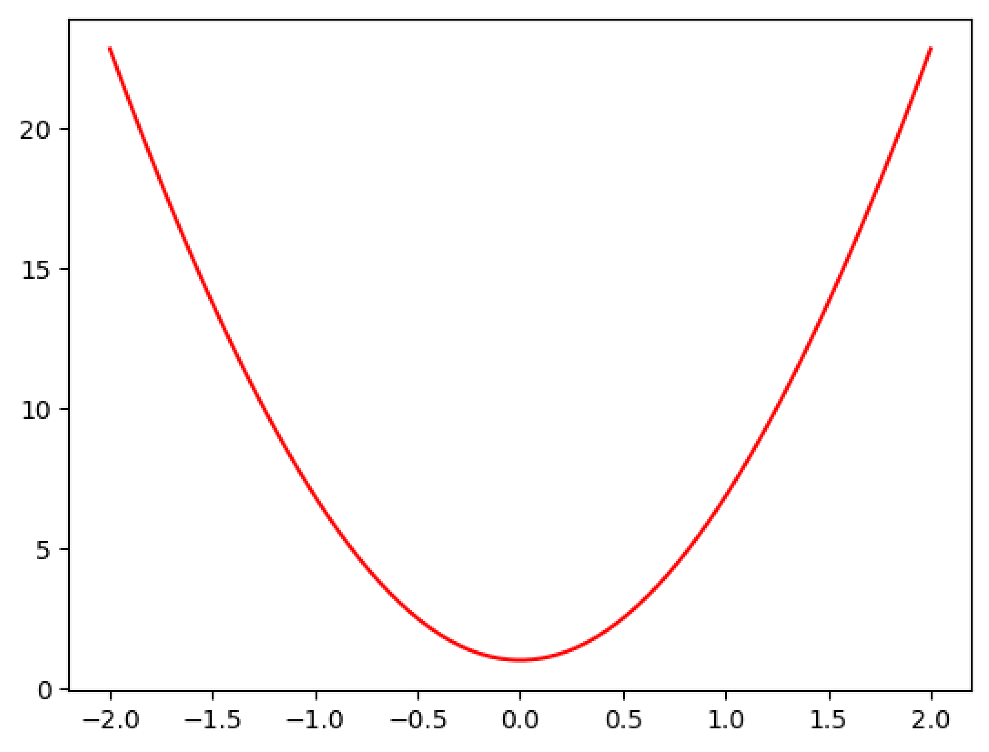

|  |
| --- |
| x **=** np**.**linspace(1.9999,2.0001,10) plt**.**plot(x,f(x),"k") plt**.**show() |

In [134…

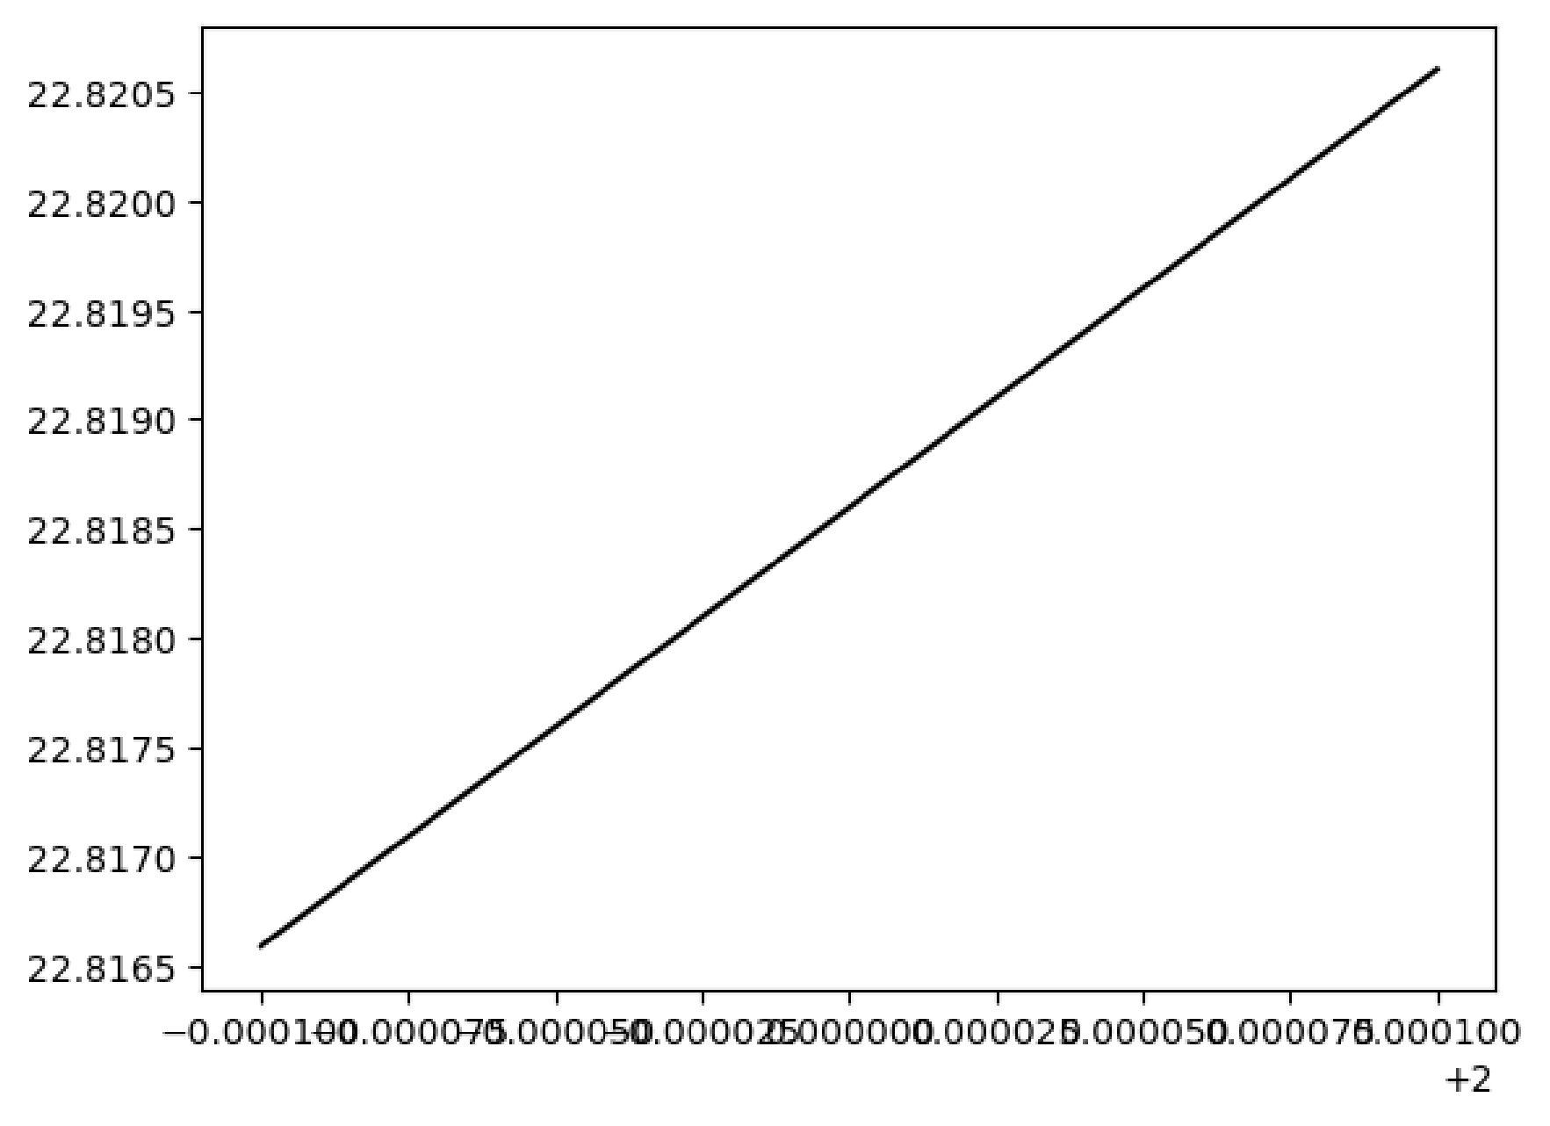

In [135…

limite à gauche

[1.9999 1.99999 1.999999]

|  |
| --- |
| Vgauche **=** np**.**array([1.9999,1.99999,1.999999])  print("limite à gauche") Ugauche **=** f(Vgauche) print(Vgauche) print(Ugauche) |

|  |
| --- |
| Vdroite **=** np**.**array([2.000001,2.00001,2.0001])  print("limite à droite") Udroite **=** f(Vdroite) print(Vdroite) print(Udroite) |

[22.81658719 22.81839408 22.81857478]

In [136…

limite à droite

[2.000001 2.00001 2.0001 ]

|  |
| --- |
|  |

|  |
| --- |
|  |

[22.81861493 22.81879562 22.82060259] In [ ]:

In [ ]: